Sentiment Analysis Using LLM on Social Media Comments
David So^{#1}
Informatics Department, New Jersey Institute of Technology
University Heights, Newark, New Jersey 07103
United States of America
¹ds2296@njit.edu

Abstract— The US war against Iran, which started on March 1, 2026 and is still being fought as of the publication date of this report continues to accelerate the trend of rising antisemitism across the world since Hamas’ October 7 surprise attack on Israel in 2023. The purpose of this independent study is to compare and contrast antisemitic sentiment from 659 Instagram comments of two distinct Jewish advocacy organizations. This is the final submission for IS488-614, Spring 2026.

Keywords— Instagram, Social media, Comments, API, Data wrangling, Data cleaning, Sentiment analysis, Natural language processing, Large language model, Prompt engineering, Israel, USA-Iran war
- Introduction
The surprise attack carried out by Hamas against Israel on October 7, 2023 has accelerated the trend of rising antisemitism globally. This has allowed such rhetoric to flourish and spread across social media with limited regulation. Comment sections of content pertaining to the conflict function as gathering areas and echo chambers for the expression of the sentiment to be analyzed. Most of this text data is semi-structured, requiring advanced techniques in data wrangling and cleaning prior to performing sentiment analysis by prompting an LLM.
- Context-Timeframe Focus
- Jewish Advocacy Organizations

- Jewish On Campus: JOC is a niche-level campus organization with multiple chapters across college campuses in the United States. Founded by university students during the COVID-19 pandemic, their posts highlight the experience and struggles of being a Jewish college student in contemporary times. [5] Members of this organization occupy a smaller age range, mainly adolescents and young adults belonging to Gen Z.
- Stand With Us: SWU is a large legacy Jewish advocacy organization focused on “supporting Israel and fighting antisemitism around the world”. [6] Their posts on Instagram reinforce the canonical definition of “Zionism” as the right to Jewish self-determination in their native land. Members of this organization span multiple age generations, from the young to elderly.

- Timeframe Focus: March 1, 2026 to May 8, 2026
The US initiated a military operation against Iran on March 1, 2026 after refusing to yield to President Donald Trump’s demands regarding the ongoing nuclear deal. Oil prices have skyrocketed since the blockade of the Strait of Hornuz in the Persian Gulf started, with gas prices rising daily[3]. Focusing on this timeframe ensures consistent temporal and geopolitical context across comment rhetoric.

- Objective and Target
- Research Question
What differences in rhetoric are present in the comments for each separate advocacy organization, and what does that reveal about overarching antisemitic sentiment across different generational spheres?

- Technique and Execution
The pipeline architecture consists of two parallel and identical data wrangling and cleaning processes that converge at the stage when the LLM is called to perform sentiment analysis using custom-written compare-and-contrast prompts.
- Methodology

- API Data Wrangling
Instagram itself does not allow access to post metadata unless the user owns a business account and can only access what they own. Public account scraping requires a paid API subscription to circumvent this restriction.

A data wrangling script generates a Parquet file containing raw comment text and its metadata after the API key is obtained. Filtering comments by date requires calls to two endpoints— the architecture does not allow developers to directly pass their desired parameters directly.

- Post Information (POST Request): The first endpoint accepts the account username and the date range as parameters, set as global variables. The script uses the POST method to extract the post id and its media code for every post in the date range made by each account, and saves those values into an array.

- Comment Text (GET Request): The second endpoint only accepts the parameters taken from the hidden metadata taken from the first endpoint. Raw comment text can only be extracted if the first endpoint returns a valid set of hidden metadata parameters. A GET request is sent for every parameter corresponding to a valid post, and returns the raw comment text. A dataframe is created then saved to a Parquet file in the project directory, maintaining pipeline modularity.

- Raw Data Cleaning - Demojization

Usage of an LLM greatly reduces the need for traditional NLP preprocessing such as tokenization and lemmatization. Instead, emojis must be converted into words from their Unicode representation to enhance LLM comprehension of sentiment. Encoding is done in three stages:

- Intensity Marker: Detects repeating emojis typed together and assigns an “intense” tag before the literal encoded meaning, such as “INTENSE_CRYING_FACE”. This makes it easier for the LLM to understand emotional response magnitudes in the text.

- Bigrams and Trigrams: Alternating and mixed emoji sequences are encoded next. These contain shorthand expressions for complex emotions and political dog whistles that the LLM might not understand if passed only the raw emoji values.

- Singular Encoding: Any remaining emoji not encoded by the first two stages simply gets replaced with its literal meaning string, and the resulting dataframe is saved into another Parquet file containing the raw and encoded comments.

- Sentiment Analysis - Gemini 3.1 Flash Lite [2]
- Prompt Engineering:
- The preliminary rhetorical analysis is functionally equivalent to exploratory data analysis in traditional machine learning. The LLM is prompted to perform rhetorical analysis and compare the comments taken from each account, returning a short and concise summary.
- Based on the rhetorical analysis, the LLM is prompted to assign a vector score for each comment, with each dimensional component representing political alignment, the intensity or rebuttal of hate and bigotry, and strong collective emotion such as grief or anger.

- Visualisation with seaborn, plotly, matplotlib:
- The vector scores range from -1 to +1 inclusively for political alignment and hate speech. These scores are placed scatterplot with the appropriate dimensions, with a regression line or hyperplane to visualise correlation between vector components.
- The collective emotion score is scalar, ranging from 0 to 1 inclusive. A simple histogram shows the distribution of emotionally charged and intense comments.
V. Discussion of Findings
- JewishOnCampus
- Countering antisemitism: Comments with a strong negative Y score do not have a strong political alignment (X score). Their rhetoric does not employ right nor left wing political rhetoric, implying the use of personal and social ethics, or centrist beliefs for justification.
- Antsemitic comments: These have high positive Y scores and are split across the political spectrum X score. This clearly suggests antisemitism is expressed using far right or left political ideology as justification.

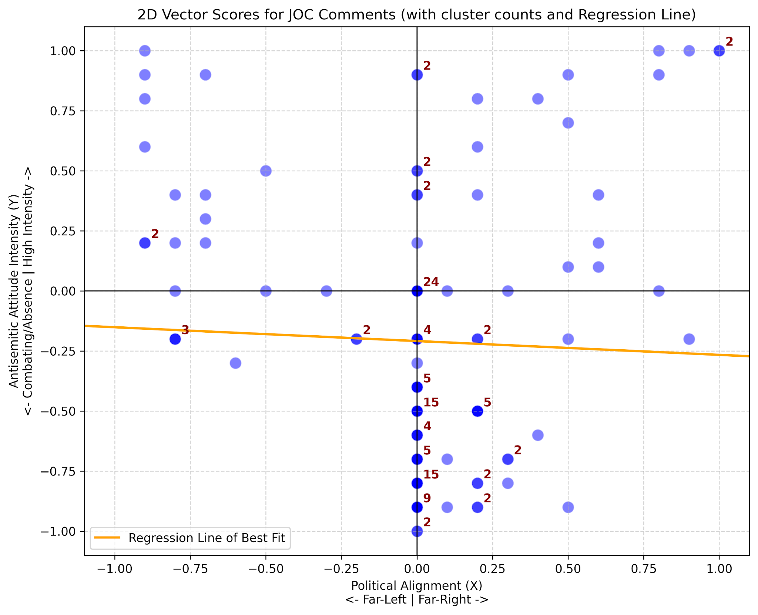
Plot 1: 2D scatterplot for JewishOnCampus comments

- StandWithUs
- Canon Definition of “Zionism”:
Strong, collective emotions such as grief and solidarity dominate the overall rhetoric, with over 130 comments out of 440 having a score of 1, the maximum and the mode. The number of comments in each interval constantly decreases for every decrement in score.

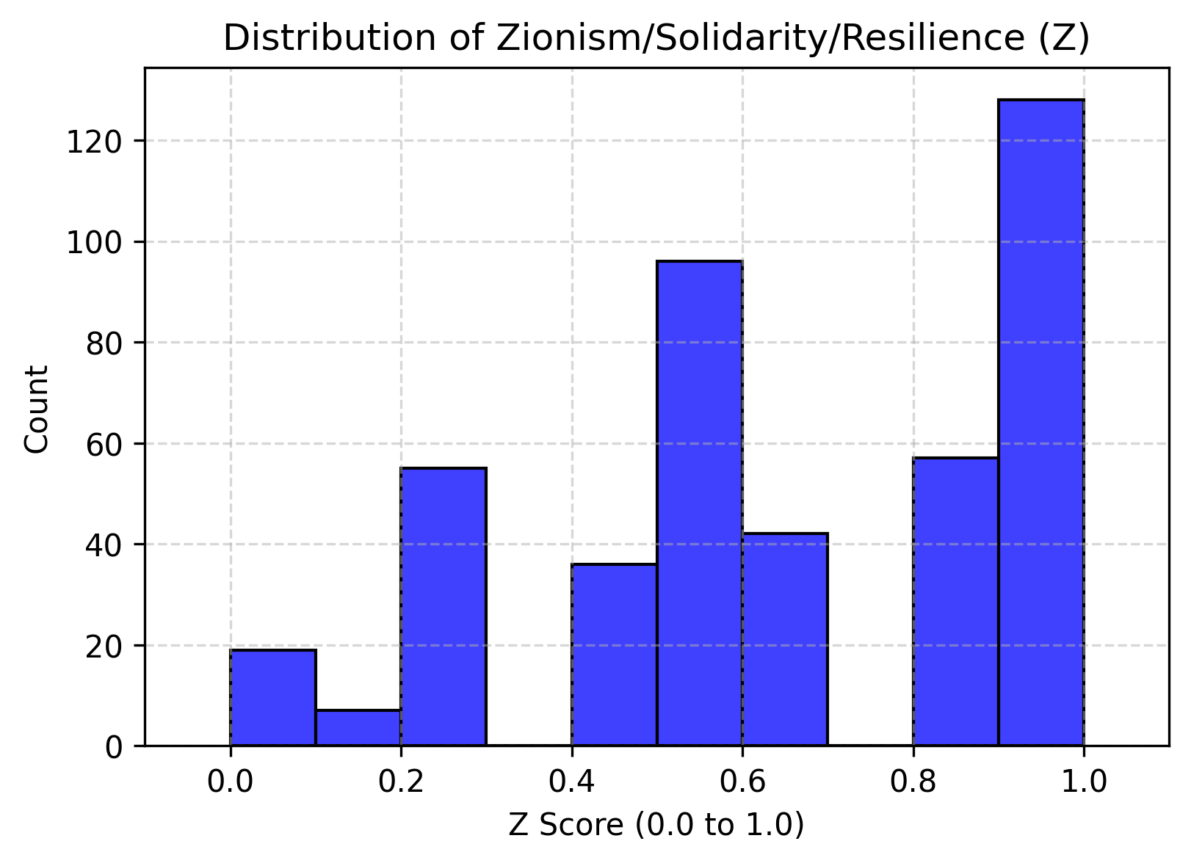
Plot 2: Histogram of strong collective emotion score
- Strong Countering Against Antisemitism:
The majority of comments show strong resistance to antisemitism using collective strong emotions (pathos) and personal ethics (ethos) as justification. Most of the comments in this category use minimal or centrist political rhetoric. The ones that do use political rhetoric are right-leaning. Contextually, these combat left “progressive” antisemitism often dressed as criticism of Israeli policies.

- Bigotry and “Othering”:
The out-group refers to any non-Jewish person in this context, and the bigotry score component ranks the “us vs. them” rhetoric for every comment. This score is most correlated with the political alignment score: a large number of right-leaning comments use exclusionary language.

Of those comments with a right-leaning and high-bigotry score, their rhetoric becomes more charged when countering antisemitism. The triple correlation implies a tribal approach: defending one’s own kind uncompromisingly.

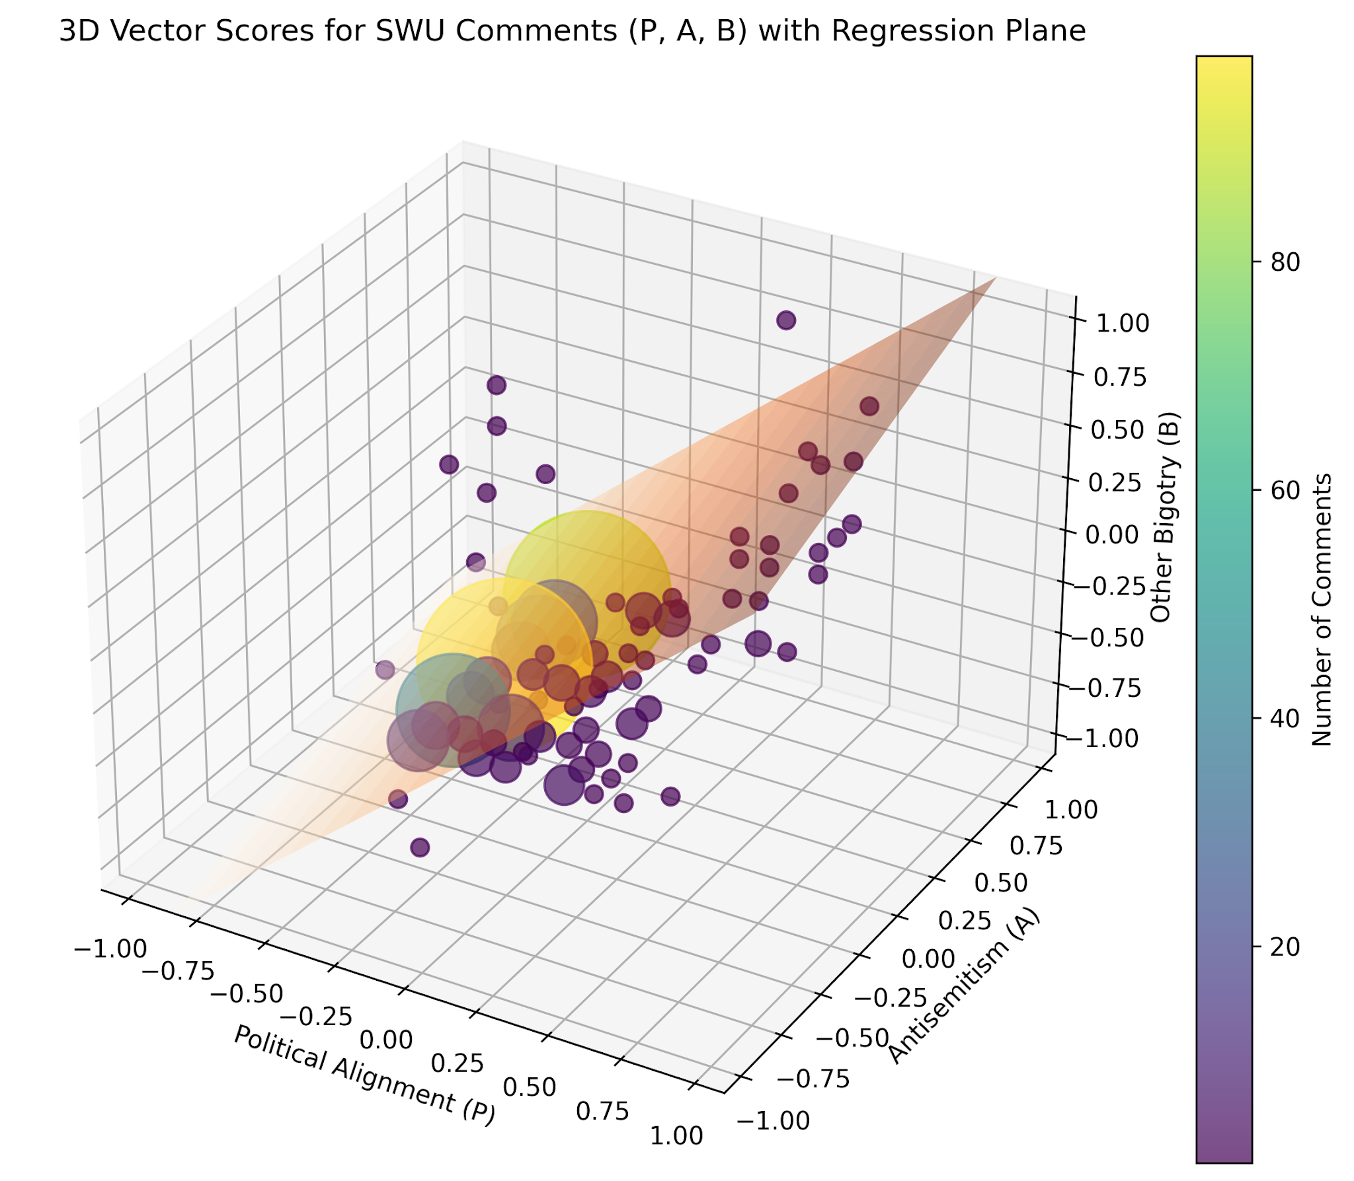
Plot 3: 3D scatterplot For SWU scores
VI. Broader Implications and Conclusion
- Endurance of Antisemitism
“The world’s oldest form of hatred” lives up to its reputation in endurance. Tribalism, bigotry, and othering allow antisemitism to flourish. The spread of lies, intentional or not creates the environment needed for hate to spread regardless of the time period in human history.

- Small vs. Large Organization
- Compare: Across all comment sections, both small and large advocacy organizations counter antisemitism mainly by avoiding polarization and using logic and ethics as justification. Rationality effectively counters hate which is intrinsically irrational.

- Contrast:
- JOC, consisting of mainly Gen Z college-age individuals express antisemitism through a polarized and often politically-motivated lens, creating a “horseshoe” effect.
- A part of SWU’s multigenerational platform tend to lean right if not centric. Right alignment is used to express a sense of unity in combating antisemitism by defining it as an in vs. out-group battle.

- The Internet’s Role
The internet as a whole, and particularly social media have allowed faster dissemination of information with a caveat: lies can spread like wildfire across the world as opposed to a small region centuries ago. Media literacy is more important than ever: it may stop someone from going down the path of hate.
Acknowledgements
David So wishes to thank Julie R. Ancis, Distinguished Professor for supervising this independent study, Matthew A. Toegel, University Lecturer for his mentorship on API scripts, and Zhi Wei, Distinguished Professor for inspiring the pipeline architecture. He also wishes to thank New Jersey Institute of Technology for granting him high-tier access to Google Colaboratory and Gemini Apps necessary for the completion of this project.
References
- Ancis, J. R. (2025). Cyberpsychological Investigations of Social Media and Online Antisemitism: the Scholarly Landscape. Journal of Contemporary Antisemitism, 8(1), 63–74. Retrieved 27 October 2025. https://doi.org/10.26613/jca/8.1.183
- Ancis, J.R. (2025) Countering Online Antisemitism: Analyzing Social Media Influencers' Strategies for Disrupting Hate Speech . Retrieved 27 October 2025. https://ssrn.com/abstract=5327982
- 60 Minutes. (2026, March 15). Strait of Hormuz disruption threatens to shake global economy [Video]. YouTube. https://www.youtube.com/watch?v=GYQ5yGV_-Oc
- Google. (2026). Gemini (Flash Lite 3.1 version) [Large language model]. https://gemini.google.com
- Jewish On Campus [@jewishoncampus]. (n.d.). Posts [Instagram profile]. Instagram. Retrieved May 9, 2026, from instagram.com
- StandWithUs [@standwithus]. (n.d.). Posts [Instagram profile]. Instagram. Retrieved Apr 27, 2026, from instagram.com

